**Screen 1: Running bamazoncustomer.js in node and showing inventory**

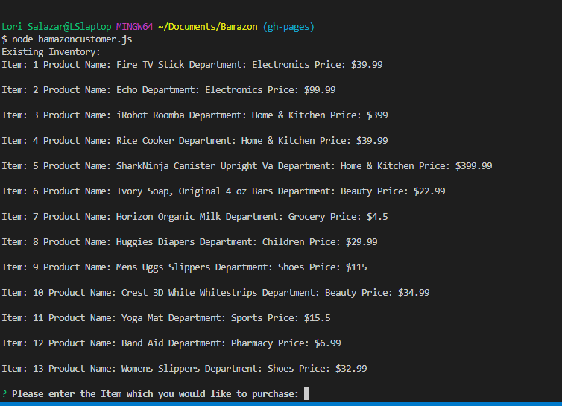

**Screen 2: Select item to buy (9- Mens Uggs Slippers) 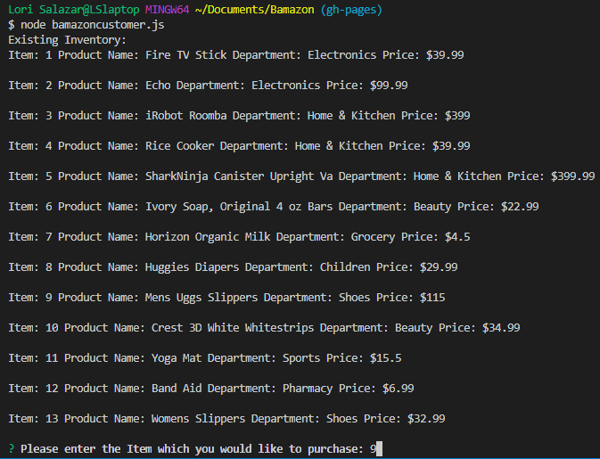 Screen 2: Select quantity to buy (9- Mens Uggs Slippers), 36, not enough in stock**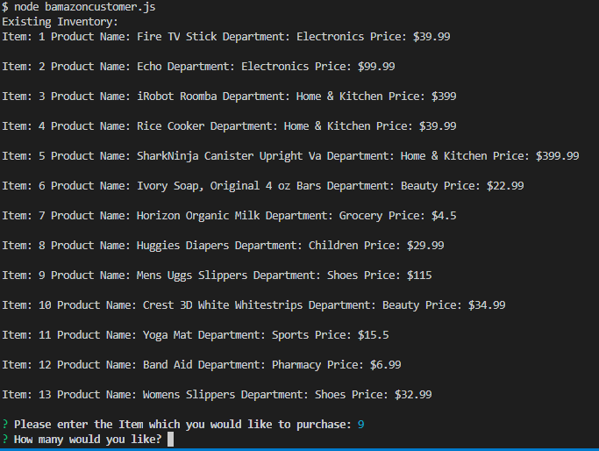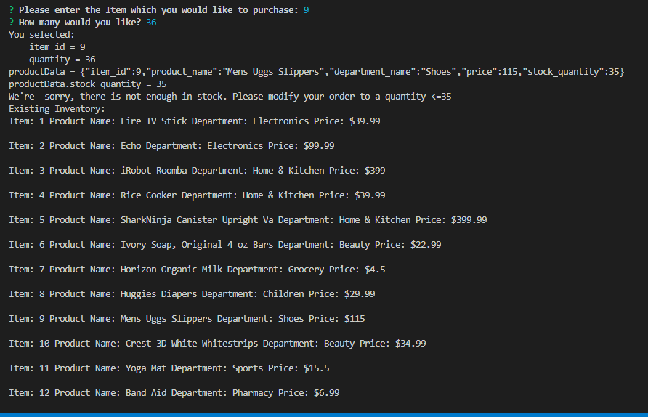

**Select typed in 0 then negative number (9- Mens Uggs Slippers), error msg** 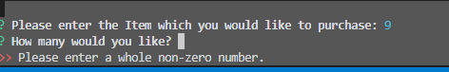

**Typed in quantity 10 (9- Mens Uggs Slippers), order placed** 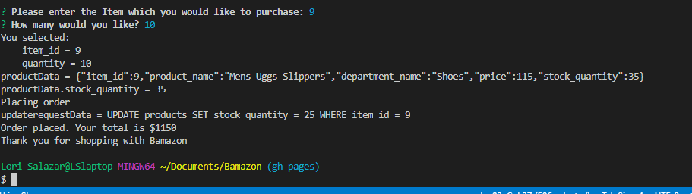

**Now run the manager application: “node bamazonManager.js” Prompts:**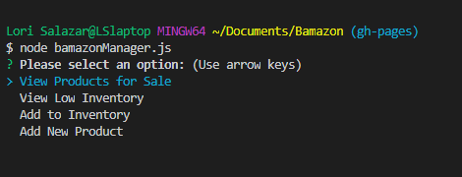

**Manager application: select View Products for Sale:**

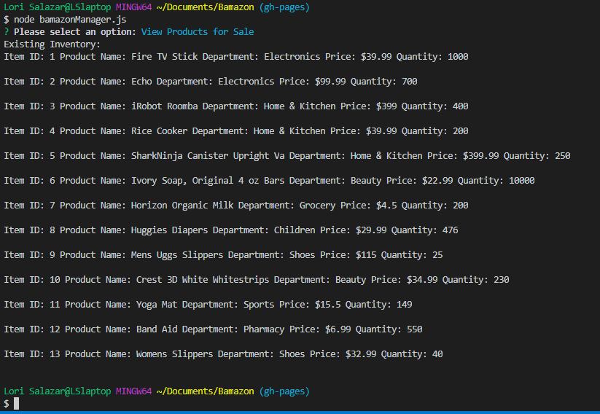

**Manager Application: select View Low Inventory (<100)**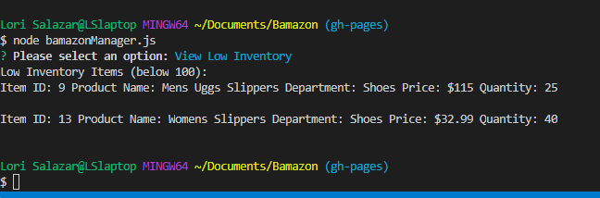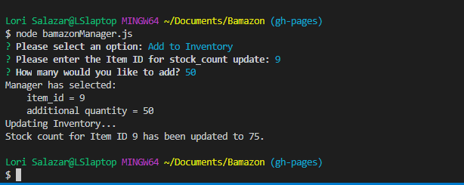

**Manager Application: Add 50 to Inventory to Uggs slippers (was 25 now 75)**

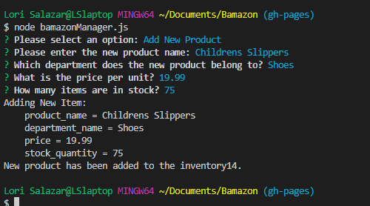

**Show Final Inventory with New Item (Children’s slippers) added, Uggs Slippers +**

**Add New Product – Childrens Slippers**

